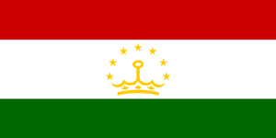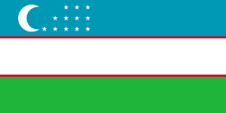

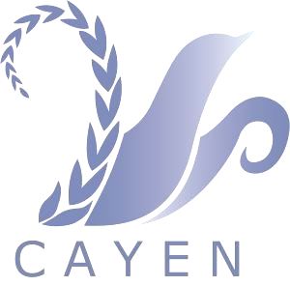

Report
7-th INTERNATIONAL CAYEN MEETING
WITH CENTRAL ASIAN
EXPERTS PARTICIPATION.
Public Participation in Strengthening of Regional Cooperation on
Environmental Governance, Climate Change, and Green Economy Development

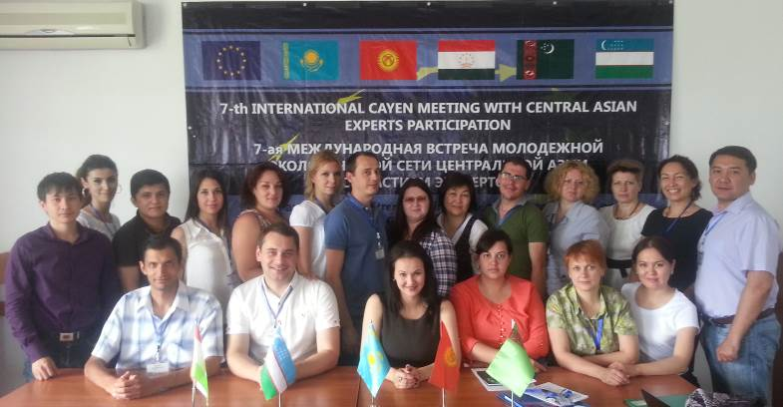

(Almaty, 13-14 June 2014, Altyn Kargaly Hotel)

Organized by
CAYEN Secretariat with the support of the WECOOP project of European Union and UNEP AP
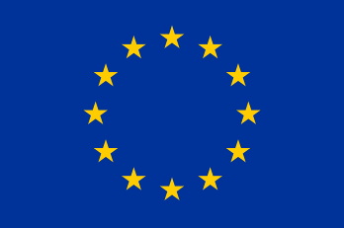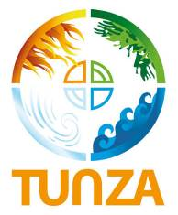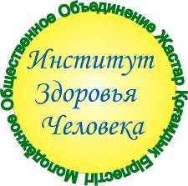

Youth Environmental Network of Central Asia (CAYEN) was established at the meeting of International Commission for Sustainable Development (ICSD) in September 2006. Since then, the Youth Environmental Network is an active participant of ISDC programs and projects and has one vote in the public council of ICSD. Youth Public Association "Institute for human health", Kazakhstan is the Secretariat of CAYEN.
Regional meeting of CAYEN in Almaty within the project WECOOP of European Union allowed Central Asian youth to improve their competence in the field of environmental impact assessment, climate change, energy efficiency and green economy which are priorities of the global environmental policy.
Global economic growth over the past 50 years has been achieved due huge cost for environment and ecosystems that are natural capital which forms the basis for the creation of wealth, human welfare and security. While world GDP rise more than doubled in the period from 1981 to 2005, 60 percent of the world's ecosystems are degraded. These patterns of growth and development due to the consumption of natural capital ultimately undermine livelihoods and the poor and vulnerable segments of society become even more vulnerable.
Many crises have arisen or are accelerated in the last decade: the crises in climate, biodiversity, food, fuel and water, and more recently - the financial crisis. Green economy is increasingly viewed as an economic instrument for sustainable development.
Public participation and development of youth initiatives in Central Asia, Climate change, energy efficiency and green economy are topics of 7-th CAYEN meeting, which was held on 13-14 June 2014 in Almaty, Kazakhstan. Meeting is organized by the Secretariat of CAYEN and supported by WECOOP project, co-financed by UNEP. The meeting brought together young leaders from Central Asia to strengthen cooperation, exchange experiences and discuss topics relevant to youth environmental issues related to the green economy, climate change, energy efficiency.
Purpose of meeting: To assist and support the Central Asia Youth Environmental Networks with capacity building on climate change, energy efficiency and green economy.
Participants: Representatives CAYEN member organizations, national and international experts.

AGENDA
Almaty, “Altyn Kargaly”, 13-14 June 2014
Time | Sessions
Day 1
10:00 | GENERAL OPENING SESSION  - Welcoming address of the EU Delegation in Astana, Ms. Alia Baidebekova  - Welcoming address of the IFAS, Mr. D. Bayalimov  - Welcoming address of CAYEN secretariat, Mr. D. Tereshkevich
10:10 | Review of the Regional Environmental Initiatives (Regional Environmental Action Plan, Framework Convention on Environmental Protection and others) – Public Council of ICSD, CAYEN Secretariat, Mr. Dmitriy Tereshkevich
10:35 | WECOOP - Lessons Learned – Mr. Anatoly Krutov
 | CAREC – Centre of Knowledge – Ms. Lyudmila Kiktenko
11:00 | Coffee – break
11:30 | Session 1. Green Economy  Moderator – Mr. Dmitriy Tereshkevich  The objective of this part is to discuss Green Economy perspectives in Central Asian countries, best practice across the Globe and possible implementation of green economy principles in Central Asia
11:40 | Green Economy: Objectives and Instruments – Mr. Bulat Yessekin
12:10 | CAREC – Green Business Club – Ms. Aray Shulgauova
12:30 | Energy Efficiency and Green Economy Policy in Kazakhstan – Mr. Dmitriy Tereshkevich
12:50 | Green Economy and Waste – Mr. Almat Satubaldyn
13:00 | Lunch
14:00 | Global Market and Green Economy – Mr. Murat Temirbekov
14:30 | Discussion and Recommendations
15:00 | Session 2. Climate Change  Moderator – Mr. Timur Idrisov, NGO “Little Earth”  The objective of this part is to discuss Climate Change in Central Asia and review of national and international assessments and practice in this field
14:10 | Climate Change. Review of the Central Asia Climate Change Policy – Ms. Aliya Tonkobayeva, PF Asian-American Partnership
15:40 | Central Asia in Climate Change Negotiations – Mr. Timur Idrisov, NGO “Little Earth”
16:00 | Coffee – break
16:30 | Kyoto protocol 2013-2020 – Mr. Vadim Ni, PF Asian-American Partnership
17:00 | BAT for Adaptation to Climate Change – Mr. Sergey Belov
17:30 | Discussion and Recommendations
18:00 | Dinner
Day 2

10:00 | Session 3. Strengthening of Public Participation in Environmental Governance.  Moderator – Ms. Nina Kadantseva (Badreyeva)  The objective of the session is to discuss opportunities for Civil Society across Central Asia in the decision making on the subregional level on different environmental issues including green economy, climate change and water.
10:10 | Public Participation in Environment Decision Making – Ms. Inna Konyukhova
10:40 | Central Asian Youth Environmental Networks presentations  Ms. Alina Ismailova - Uzbekistan  Ms. Mariya Savickaya - Kazakhstan  Ms. Victoriya Saygusheva - Turkmenistan  Mr. Dmitry Tereshkevich – CAYEN Secretariat  Mr. Dmitriy Vetoshkin – Kyrgyzstan  Mr. Timur Idrisov - Tajikistan
11:00 | Coffee – break
11:30 | Central Asian Climate Change Network – Ms. Elina Doszhanova
11:50 | Central Asian Water Network – Ms. Vera Mustafina
12:10 | Public Participation in EIA. Case Studies - Ms. Svetlana Spatar
12:30 | Discussion and Recommendations
12:40 | General Discussion
12:50 | Close of the Seminar
13:00 | Lunch

Sheet of the participants for the CAYEN meeting
Participant’s Name |  | City | Place of work
Dmitriy Tereshkevich | Kazakhstan | Astana | Human Health Institute | Activist
Murat Temirbekov | Kazakhstan | Astana | Human Health Institute | Activist
Nina Kadantseva | Kazakhstan | Ridder | YEN Kazakhstan | Activist
Diana Badreyeva | Kazakhstan | Ridder | YEN Kazakhstan | Activist
Aliya Tonkobayeva | Kazakhstan | Karagandy | YEN Kazakhstan | Activist
Mariya Savitskaya | Kazakhstan | Karagandy | YEN Kazakhstan | Activist
Aydar Kapassov | Kazakhstan | Karagandy | YEN Kazakhstan | Activist
Alfiya Nasyrova | Kyrgyzstan | Bishkek | YEN Kyrgyzstan | Activist
Inna Konyukhova | Kyrgyzstan | Bishkek | YEN Kyrgyzstan | Activist
Indira Zhakipova | Kyrgyzstan | Bishkek | YEN Kyrgyzstan | Expert
Dmitriy Vetoshkin | Kyrgyzstan | Bishkek | YEN Kyrgyzstan | Expert
Rustam Murzakhanov | Uzbekistan | Ташкент | YEN Uzbekistan | Activist
Alina Ismailova | Uzbekistan | Ташкент | YEN Uzbekistan | Activist
Natalia Kamilova | Uzbekistan | Ташкент | YEN Uzbekistan | Activist
Timur Idrisov | Tajikistan | Dushanbe | YEN Tajikistan | Activist
Tolisjon Artiqov | Tajikistan | Khujand | YEN Tajikistan | Activist
Natalia Idrisova | Tajikistan | Dushanbe | YEN Tajikistan | Activist
Sulhiya Ayubova | Tajikistan | Dushanbe | YEN Tajikistan | Activist
Victoriya Saygusheva | Turkmenistan | Ashgabad | YEN Turkmenistan | Activist
Maral Ilyasova | Turkmenistan | Ashgabad | YEN Turkmenistan | Activist
Irana Bagirova | Turkmenistan | Ashgabad | YEN Turkmenistan | Activist
Aynabat Atayeva | Turkmenistan | Ashgabad | YEN Turkmenistan | Activist
Dayanch Hodgageldiyev | Turkmenistan | Ashgabad | YEN Turkmenistan | Activist
Alia Baidebekova | Kazakhstan | Astana | EU Delegation | Expert
Diana Bayalimov | Kazakhstan | Almaty | IFAS | Expert
Anatoly Krutov | Kazakhstan | Astana | WECOOP | Expert
Lyudmila Kiktenko | Kazakhstan | Almaty | CAREC | Expert
Aray Shulgauova | Kazakhstan | Almaty | CAREC | Activist
Bulat Yessekin | Kazakhstan | Almaty | YEN Kazakhstan | Expert
Almat Satubaldyn | Kazakhstan | Almaty | YEN Kazakhstan | Expert
Vadim Ni | Kazakhstan | Almaty | CAYEN | Expert
Sergey Belov | Kazakhstan | Almaty | YEN Kazakhstan | Expert
Elina Doszhanova | Kazakhstan | Almaty | YEN Kazakhstan | Activist
Vera Mustafina | Kazakhstan | Almaty | YEN Kazakhstan | Expert
Svetlana Spatar | Kazakhstan | Almaty | YEN Kazakhstan | Expert

Minutes of Meetings
June 13, 2014
Moderator: D. Tereshkevich
Secretary: N. Kadantseva
Was attended: representatives of CAYEN members, experts
Speeches:

1. Welcoming address from the Secretariat of CAYEN, Mr. Dmitry Tereshkevich;
2. Welcoming address from the WECOOP Project Director Mr. Michael Parker.

Meeting: Meeting was conditionally divided into three main sections - Green economy(1), climate change and energy efficiency (2), public participation (3). Each unit is made by experts with thematic presentations. The meeting also highlighted historic aspects of environmental activities in Central Asia, including IFAS, ICWC, ICSD, CAYEN, CAREC. Goals and objectives of the structural units of IFAS been announced at the meeting. Brief review of the outcome of the WECOOP project and its web-platform www.wecoop-project.org presented.

Green Economy discussed topics:
Objectives and instruments of "green economy" (national policies and programs, standards, including building codes, reducing pollution, tax and tariff reform, stimulating green-technologies and innovations); the outcome of Rio +20; historical tendencies in the development of industries and consumption; partnership program "Green Bridge"; waste management, global market and green economy.

Climate Change and Energy efficiency topics:
Climate Change: Causes and Consequences; water scarcity, population growth; energy and green technologies at the global scale; development of innovative renewable energy technologies; adaptation to Climate Change (ecovillage and original forestry ecopolis; policy on Climate Change in Central Asia, an overview of the position of the Central Asian countries on climate change, the recent positive changes and positions on UN climate negotiations, the Kyoto Protocol 2013-2020. second crediting period, the legislative framework of energy-savings.
Strengthening public participation in environmental policy aspects:
Public participation in the environmental debates, public participation in international environmental actions and campaigns, public participation in the framework of the Central Asian Network on Climate Change and Central Asian water network. Public participation in the EIA process. EIA legislative framework in Central Asia. Example of Public participation in EIA through "Kok Zhailau" campaign.
At the end of thematic presentations CAYEN organizations presented their experience in the field of climate change, resource and energy efficiency, green economy.
CAYEN adopted resolution of the meeting which determines the main directions of network development for 2015-2016 years. Participants pointed tasks for CAYEN Secretariat and National Coordinators on climate change, energy efficiency and green economy. CAYEN prepared proposals to WECOOP for the further cooperation with European Union projects.
Resolution
of the 7-th INTERNATIONAL CAYEN MEETING WITH CENTRAL ASIAN EXPERTS PARTICIPATION. Public Participation in Strengthening of Regional Cooperation on Environmental Governance, Climate Change, and Green Economy Development

We, the young leaders, youth environmental movements and organizations of Central Asian countries, members of the Youth Environmental Network of Central Asia (CAYEN) considered public participation, climate change, energy efficiency and the transition to a "green economy" issues and we expressing our readiness for
- promote a lifestyle based on reasonable consumption, taking into account the potential of natural resources,
- Information dissemination about sustainable development and promotion of experiences exchange on best practices between different countries.
- conducting environmental activities and campaigns aimed to solve specific environmental problems;
- continue to work in the field of environmental protection:
- Work with children, adolescents and youth for environmental education;
- Carrying out environmental campaigns and actions,
- Reforestation,
- Development of eco-tourism, etc.,
We are ready to strengthening our efforts on:
• Information exchange
•Environmental Education;
• Youth participation in environmental decision-making;
• Capacity building of youth environmental organizations.
Tasks for CAYEN Secretariat to work out:
1. Express gratitude to WECOOP project and UNEP office in Asia Pacific for support of the 7th CAYEN meeting.
2. Arrange together with Central Asian Water Network seminar for youth on water issue in Central Asia
3. Cooperation with business campaigns for youth involvement in the promotion of the Green Economy
4. Optimize CAYEN site together with NGO BIOM
5. Prepare databases of CAYEN
6. Start to prepare for the next meeting of ICSD and next CAYEN meeting
Tasks for Coordinators of national networks
1. Prepare a workplan for 2015-16 years
2. Conduct discussion in countries on climate change, energy efficiency and green economy
3. Prepare overviews of CAYEN members activity (events, actions, camapanies)
4. Provide to Secretariat with updated lists of members of the network as of 2014.
Proposals for WECOOP project, other projects of the European Union and UNEP for further cooperation
In order to assist in strengthening regional cooperation of European Union and Central Asia countries for protection of environment, water resources, in line with the EU-Central Asia strategy we are asking to support the following initiatives of CAYEN:
1. Joint meeting of CAYEN and ICSD Public Council to join forces on climate change, energy efficiency and "green economy" with purposes to cooperate and collaborate with existing ICSD structures
2. Increase the capacity of youth through hosting and organizing specialized trainings, seminars and workshops, retreats camps in the field of​climate change, energy efficiency and "green economy;
3. Support participation of CAYEN members in high-level meetings, working groups, initiatives and projects on climate change, energy efficiency and "green economy"
4. Preparation and production of informational materials of CAYEN:
• Analytical report - best practices of youth in climate change, energy efficiency and "green economy"
• Information materials for the public (brochures, leaflets, booklets, posters, videos, etc.) to explain the importance of implementation of green and eco-friendly technologies, saving energy and resources and simple methods for the calculation of the profit saved from effective energy and resources using and eco technology transfer.
• Support CAYEN with modern information technology using to promote the ideas of the Green Economy (e-mail newsletters, social networks, Web-sites, cloud computing, etc.)
CAYEN plans to continue cooperation with existing networks in Central Asia, including Public Council of ICSD, CA Climate Coalition of CSOs and CA Water Network.

